Appendix 1

Summary of findings report -

The Retail Group Covered Market recommendations

The Council commissioned The Retail Group, a specialist markets consultancy, to provide a detailed assessment of the market and to identify a vision, strategy and detailed actions to improve the performance and secure the market’s role within the city centre retail hierarchy.
In line with this report the Council produced a questionnaire for members of the public to answer questions and provide feedback on the Covered Market.

The consultation began on 5th December 2013 and ended on Friday 13th December 2013.

The consultation was publicised through a number of channels including through the local press, local media, Councils website, posters and information packs at libraries in the City.

Members of the general public were invited to respond to the questionnaire through the online eConsult system. There was also the opportunity to request a paper copy of the questionnaire directly from the Council.

In total, 428 responses were received of which 426 were received through eConsult and 2 were received via paper submissions.

This summary of findings report summarises the responses received to each question.

- Question 1. How often do you visit?

The results show 26% of respondents visit once a week and only 17% several times per week. 29% of respondents visit several times per month and this is the most popular frequency for visiting the market.

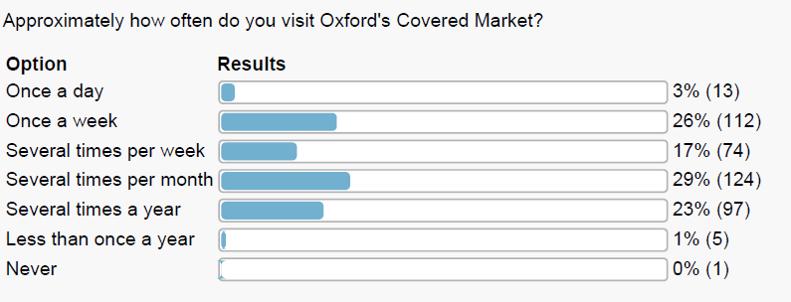

- Question 2. Why do you visit?

The highest proportion of respondents (80%) visit the market to visit a specific shop. This is followed by those who browse with an intention to buy (58%).
32% of respondents visit as a shortcut to other destinations and a similar proportion (33%) visit to browse without an intention to buy.

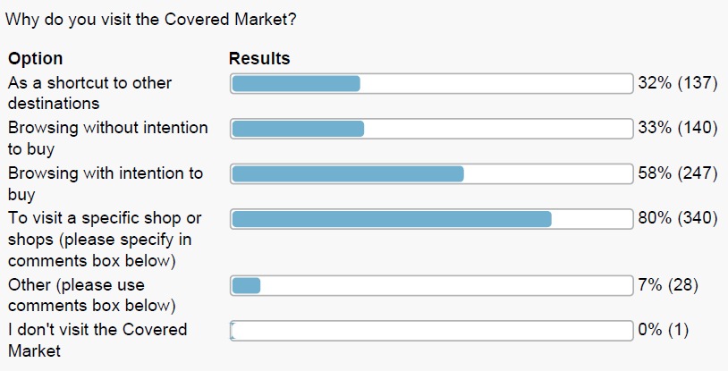

- Question 3. What do you frequently buy?

The most popular purchase is Fresh Food – (meat & fish 60%), followed by Fresh Food, fruit and vegetables (64%). Items of less interest to purchasers include clothing, footwear, fashion accessories / jewellery, homeware and giftware with all these being below 30% in terms of the percentage of respondents.

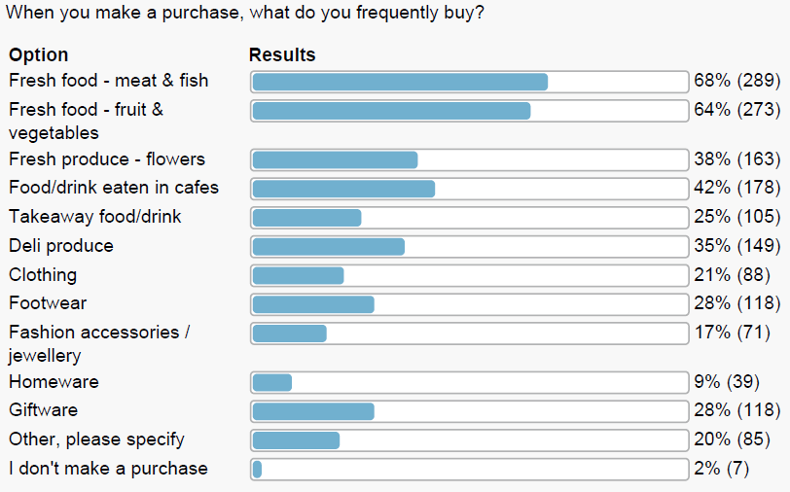

- Question 4. How do you rate quality?

Only the Fresh Food (meat & fish) offer is rated as excellent with Fresh Food (fruit & vegetables) between good and excellent and Fresh Produce (flowers) and Specialist Services (key cutting, picture framing etc.) achieving a good rating. The remaining offer of the market is largely considered as only satisfactory.

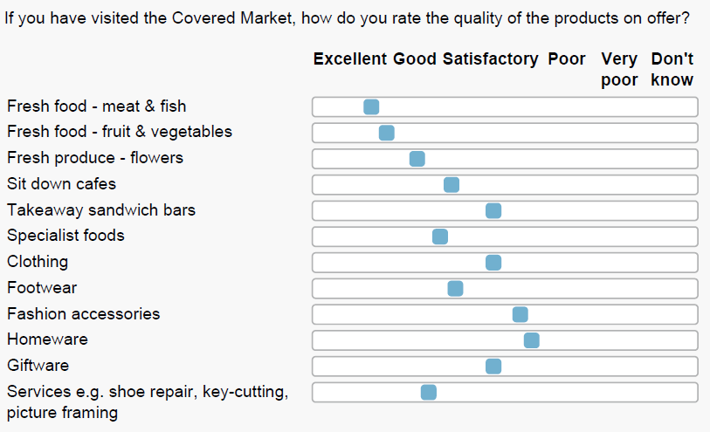

- Question 5. What would you like to see in the market?

The only item which respondents would clearly like to see more of is Fresh Food and produce. The results suggest a desire for less of all other identified items.

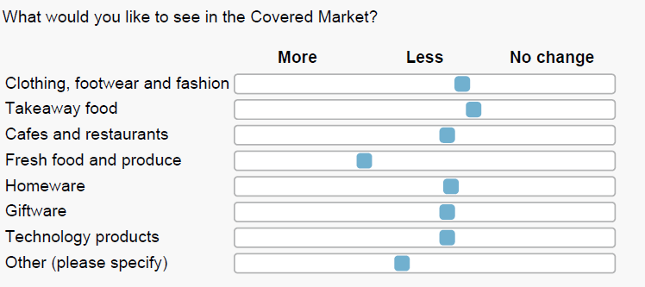

- Question 6. How would you enhance awareness?

Improved signage is considered a high priority with increased advertising, marketing and the creation of a detailed website identified as medium priority. Use of digital apps and a greater use of social media is seen as a lower priority.

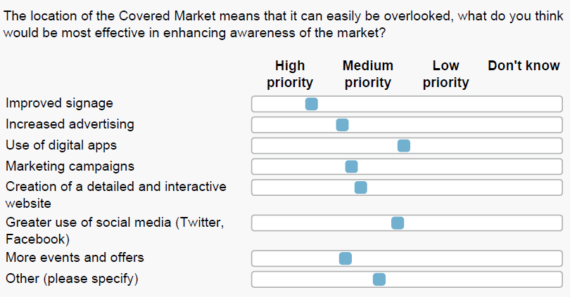

- Question 7. How would you rate the overall experience?

The results suggest the overall experience is mostly considered good although the atmosphere/buzz and customer service were both rated marginally higher between good and excellent. Cleanliness is an area which is considered satisfactory.

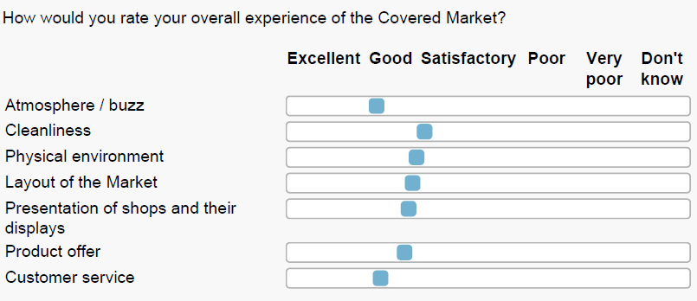

- Question 8. What would encourage you to visit more frequently?

The results suggest longer opening hours and a better physical environment are the two key items which would encourage people to visit and shop more frequently, being identified by 53% and 39% of respondents respectively. These are followed by more promotions and events, better quality of products for sale and a better food and beverage offer.

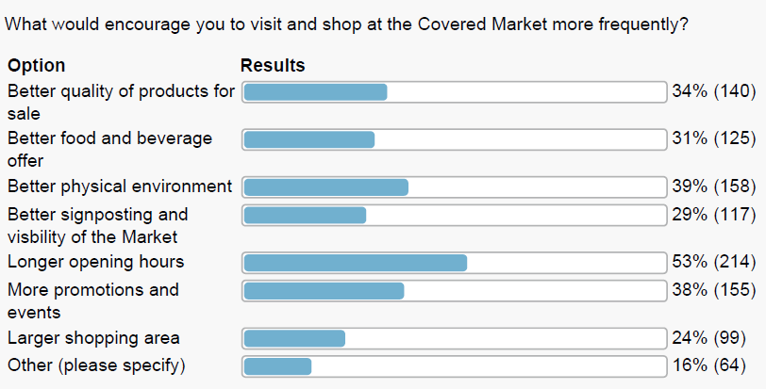

- Question 9. Do you have any other comments or feedback relating to The Retail Group Covered Market report?

This question sought to draw upon individuals responses relating to The Retail Group report and obtain feedback to the recommendations received. The comments have been assessed and categorised and the table below summarises the feedback received.

Very Supportive | Supportive | Mixed | Against | Very Against | Other
22 | 45 | 35 | 37 | 12 | 115
8% | 17% | 13% | 14% | 4% | 43%

There were a number of key themes arising from the feedback to question 9.

Keeping the character of the Market was cited numerous times together with maintaining the current integrity of the Market as a unique destination. It is apparent from the feedback that people wish to see the continuation of independent shops, which differ from the retail offer at the larger shopping centres across the Country which tend to be more brand focused. It was noted from the comments that there is a view that independent shops are able to offer speciality produce not found elsewhere on the typical High Street together with a more personal and higher quality of service.

Respondents also emphasised the need to keep rents affordable so as to ensure the traders can thrive and prosper and add something more to the Oxford retail offer. It was commented that traders in the Market could perhaps not normally afford premises in a City Centre and so the Market provides a good starting point for many new businesses starting out. Respondents wanted to see an offer that is high quality and appealing to both the Oxford resident and tourist visitor.

Respondents mentioned the need to ensure that development would need to reflect the market’s historical importance and recognise the current heritage asset that the Market is. Comments were made about the need to ensure any development needed to be made in context with the local area. For example, the colleges within the area are also of historic importance and so consideration needed to be given as to how any proposals would complement these buildings.

Respondents showed support for improving the existing signage offer as the current signage at entrances is considered not particularly visible. Comments surrounding this theme also link with other comments regarding the service delivery yard and current overcrowding of vans and cars in the area which makes the Market Street entrance look unsightly and unwelcoming. The recommendation of pedestrianizing Market Street was generally welcomed, although there was some concern over the impact reduced loading and unloading times would have on traders.

Overall, there was a good level of support for the recommendations made in the report, although a number of the comments provided mixed feedback with some comments favouring some elements of the recommendations but not others.

Out of the respondents who answered question 9, approximately 18% of the comments provided were negative towards the report and its recommendations. Approximately 38% of the comments were either supportive or demonstrated mixed support.

Appendix 2

Oxford Covered Market – Strategy for Performance Enhancement

Consultation Meetings on The Retail Group’s Study Report

- Introduction

In September 2013, Oxford City Council released The Retail Group’s report on the Oxford Covered Market for public consultation. This report contained the findings of an extensive series of bespoke research areas regarding the current performance of the market, as well as its potential going forward. The report contained a variety of conclusions in regards to which elements of the market need fixing, as well as an optimum future vision for the market, and a series of recommendations designed to help the market in the short, medium and longer term.

The Retail Group was subsequently asked to meet with key external stakeholder groups, as well as existing traders in the market, to discuss their views on the conclusions and recommendations of the report, as well as explore other areas where the market could be developed to harness its considerable potential.

- Meeting with Key Stakeholders

Representatives from The Retail Group and Oxford City Council met with key principals from Rox, Oxford Civic Society and Oxford County Council on 10th December 2013. There was broad consensus that the report successfully captured the issues the market faces and the failings that need addressing.

Rox is keen the market is not over gentrified and continues to provide part of its offer suitable for those consumers on lower incomes. Rox is also keen that the market remains dominated by independent retailers and that those retailers are provided with appropriate support to help them trade successfully. As identified in the report, Rox is keen the market retains a focus on food, with 1 or 2 additional and destination anchors needed. It is agreed that the lack of visibility and accessibility through the Golden Cross Centre is a concern. Rox is also concerned that any future development proposals would need considerable increases in rental levels, which could prove problematic for some existing independent traders.

The Civic Society also agreed with the findings of the study in so much that traffic and car / van parking on Market Street is significantly reducing the market’s appeal, on what should be its main entrance and access point. The Society would be keen to see Market Street pedestrianised. The Society is also keen to ensure that any future development plans reflect the heritage of the market and the surrounding local area in which the market is located.

From the perspective of the County Council, it broadly supports the key findings, conclusions and recommendations of The Retail Group’s report. It would also like to see significantly less vehicular movement and visibility on Market Street, as well as an improved, more visible offer and improved trader performance. It is keen that independent traders are supported going forward.

It was broadly felt the market has too much internal clutter, which is reducing its external appeal. Whilst the toilets are an important and well liked civic asset, they would be better utilised under the market at basement level, freeing up space on Market Street to help construct a new entrance.

Oxford Covered Market – Strategy for Performance Enhancement

Consultation Meetings on The Retail Group’s Study Report

- Meeting with Market Traders

The Retail Group facilitated a meeting with market traders in the evening of 10 December. All traders were invited to the meeting and 22 traders attended.

The meeting commenced with an introduction from David Edwards on the context and brief for the report, as well as the Council’s aims from the study and consultation process. This included clarification that the recommendations and ideas in the report are only that; they are not adopted policy and will require further detailed planning and thought before they are implemented.

The Retail Group then recapped on the objectives of the study and summarised the key findings and conclusions of the report. The workshop attendees were then split into 3 groups, with the objective of further developing some of the recommendations of the report, as well as giving the opportunity to introduce new ideas and best practise initiatives seen elsewhere.

Activity 1 Group 1 – Improving the marketing and promotion of the Market

- Provide a clear Directory of Traders at each entrance point to the market
- Remove parking from the 3 bays nearest to Cornmarket on Market Street; and use this space to sign post the market;
  - this will also increase visibility to the market
  - use the space for an entrance sign, possibly free standing
- Entrances to be illuminated
- Entrance signage to be easily readable, horizontal
- Touch screen display boards at entrances
- Redesign High Street signs and illumination
- Entrances to be readily identifiable
- Introduce trading stalls into entrances on High Street, narrow stalls or even glazed display cases
- De-clutter entrances, remove A boards
- Install ‘Welcome to....OCM’ (or consumer brand).

It is clear from the comments made, that traders support a focus in the report on improved entrances to the Market. Other initiatives include;

- Develop a collective web site, that promotes the market and its traders; this should link to traders’ business web sites and vice versa
- Web site to be separate from council web site
- Web site to be managed and maintained by new Head of Markets
- Develop parking initiatives, parking events to encourage repeat visits, market customer discount days, vouchers, etc.
- Develop the OCM App
- Use the internal PA system to promote traders and their promotions
- Utilise city wide opportunities for remote signage and promotion
- At arrival points
- At bus stops
- Broad Street
- Railway Station
- On buses
- Student locations
- Work force locations
- Bicester Village
- Westgate
- Hotels and B&B.
- Look at National Trust for lessons to learn
- Plan collective promotions and develop a promotional calendar
- Consider a loyalty card.

Traders are also keen for additional promotional activity. Self-funded, communal funding and shared funding were all discussed.

Activity 1 Group 2 - How the market’s layout and signage package can be improved

Signage comments have been incorporated in Group 1.

- Improve lighting within the market and also directional signage, illuminated!
- Treat Market Street at Cornmarket as entrance point for the market
- Improved signage through Golden Cross to market
- Use the square in the market for activity
- Introduce temporary hanging banners in Market Street.

Traders agree that the market needs improved internal lighting and circulation.

Activity 1 Group 3 - How the market could be managed and operated more effectively

- There needs to be a focus on actual trading performance and the retail experience in the market, rather than just property
- Consider part-time and temporary uses in vacant stalls / shops
- Provide support and motivation to traders
- Provide a visible Market Manager with the ability to get things done, traders to provide support and heed advice. It’s a two way street!
- Visibility on budget control and activity
- Compulsory trading hours, with allowance for temporary traders in front of shops that don’t open
- Governance issues to be clarified, clarity on roles and responsibility, input from traders on selection.

There is widespread agreement with one of the key findings of the report that there has to be collective as well as individual responsibility for improvement. More joined up and pro- active management is needed.

Activity 2 Group 1 - How the offer and mix can be repositioned to improve performance

- A focus on unique, independent businesses. Indeed this is a core attribute and part of the future brand identity
- No chain operators
- Traders need help to look fantastic, external support and even trader buddy programmes
- Possibly help priority traders in key locations, although help to be available to all
- Provide a trader’s handbook to existing traders and to any visiting traders
- Increase Sunday trading; ‘one for all and all for one’. Consider temporary traders to mask closed shops
- Introduce more fresh foods
- A delicatessen is a priority
- More interesting products, interesting traders
- More anchors and footfall generators
- TIC shop or even TIC barrow (as per Lincoln)
- Have a plan and priority for vacant units
- Extend mix with temporary traders and or events, allow test trading.

Traders agree with the report that a focus on quality, destination, best in class independent traders is the right direction for the market.

Activity 2 Group 2 - How the physical configuration and layout could be improved

- Develop Market Street as the main entrance
- Relocate toilets to basement area, retain and improve as a customer facility
- Re-develop toilets space into a unit
- Provide additional communal seating and facilities
- Pedestrianise Market Street
- Repair market structure, windproof building
- Use dead frontages and space for more retail units
- Build 1st floor units
- Use service yard and space above for units.

There is support for the view that a bigger and better market, with less dead space and a new clear entrance could be successful. There is concern that continuity of trade would be difficult whilst any construction works are underway.

Activity 2 Group 3 - Increasing the performance of the Market

Many of the points raised are already identified above;

- Introduce start up businesses
- Consider some short term leases
- Provide flexible occupation
- Focus on increasing footfall, both into and throughout the market
- Work with shops on the outside
- Developed shared promotional calendar.

Traders agree more support is needed to help increase the performance of the market, including the possibility of more flexibility in leasing arrangements.

- Conclusion

There appears to be broad buy-in for the general tone and direction of The Retail Group’s study from both stakeholders and traders. Clearly many of the ideas need to be worked through and carefully planned in terms of implementation. There is understandable concern in regards to the need for detailed planning of any physical redevelopment works.

Overall, it can be concluded from the consultation meetings with stakeholders and traders that there is widespread support for The Retail Group’s recommended future vision and recommendations for the market.

Appendix 3
CEB Report Risk Register –

No. | Risk Description  Link to Corporate Objectives | Gross Risk |  |  | Cause of Risk |  | Mitigation | Net Risk |  | Further Management of Risk:  Transfer/Accept/Reduce/Avoid | Monitoring Effectiveness |  |  |  |  | Current Risk
Risk Score Impact Score: 1 = Insignificant; 2 = Minor; 3 = Moderate; 4 = Major; 5 = Catastrophic Probability Score: 1 = Rare; 2 = Unlikely; 3 = Possible; 4 = Likely; 5 = Almost Certain
CEB-001-CA | There is not sufficient budget to implement the recommendations. | I  4 | P  3 | There is no allocated budget for the recommendations other than for the appointment of an interim manager |  | Obtain detailed costings and consider other sources of funding including the traders contributing to funding of specific initiatives |  | I  3 | P  2 | Work closely with Traders in order that they can see the benefit of contributing to the cost of funding, where appropriate.
 | The medium term recommendations do not provide the benefit to the market initially identified. | 4 | 3 | The true benefits of the recommendations will only be clear following successful implementation. |  | Ensure the recommendations are fully assessed and detailed plans are prepared with full costs established. Work closely with the market traders on the consideration and implementation of the recommendations. |  | 3 | 2 | Also, ensure further involvement of other stakeholders.
 | The future strategy recommendations (i.e. increase size and new entrance on Market Street) are unable to secure the required permissions (e.g. planning permission) | 5 | 4 | The building is Grade 2 listed and is within the Central Oxford Conservation Area. |  | A detailed feasibility study would be carried out which would involve working closely with the Council’s planning department and Heritage officer. |  | 4 | 4 | Consultation would also take place with other relevant organisations such as The Oxford Preservation Society.
 | The future strategy recommendations (i.e. increase size and new entrance on Market Street) are not financially viable. | 5 | 5 | The costs are likely to be significant in view of the location, the listed building status and the fact tenants are already trading in the market. |  | A detailed feasibility exercise will be carried out to fully assess the viability of the future strategy recommendations. |  | 4 | 4 | The detailed feasibility will establish if there is a clear business case on which to proceed with the recommendations which will need to demonstrate financial viability.

